New Sweeps!

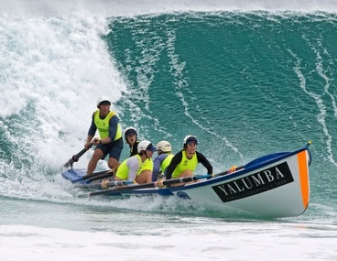

Season 2018/2019
Workshop
20th October 2018 City of Perth Surf Life Saving Club
9am – 11am (sharp)
PROGRAM
- Introduction and Welcome, Geoff Wilson, Western Australian Surf Boat Rowers Panel: Discuss with group the purpose of push for new sweeps as well as background from SLSWA – Youth focus. How the Boat Panel will help during the season; monthly meetings support from clubs or mentors from nearby clubs/sweeps
- Steve Bowler City of Perth SLSC: Leadership and how to build high performance crews
- Stuart Clark, Mullaloo SLSC: SAFETY! Some of this will be outside on the beach with a boat and part pictures on projector in training room.
- Geoff Wilson: Carnival days and how they will work with new sweeps/conditions etc.
- At the conclusion of the session, light refreshments. With thanks to Jason Wright SLSWA

Next Workshop: to be confirmed, possibly a date on the same weekend with a Boat Carnival, to encourage our country crews and sweeps to join us.
Useful References:
The Surfboat Book by Kim Marsh
SLSA – Members Portal under Documents Library/View Documents –
Surf Boat Rowing Coaching Manual 5th Edition

*** Please bring along ipads or laptops to go over online learning or if any you have questions

